Github Fresher Notes

* Cloning from public repository – go to the public github folder and click fork. This creates a folder in your own account

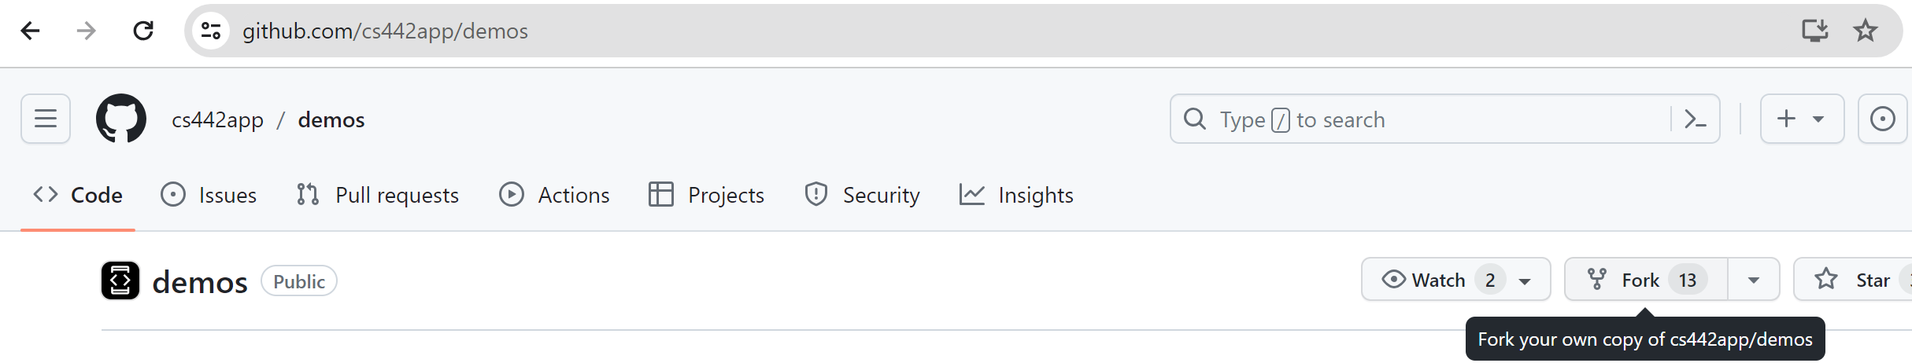

* Bring a repository from your account to VS code for editing. Click on the clone git repository link under start.
* In the search bar, now type the link of your github repository under https.

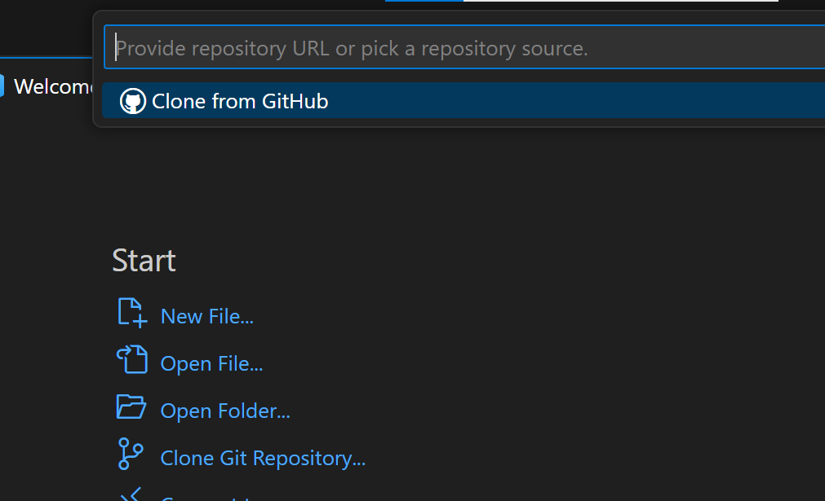

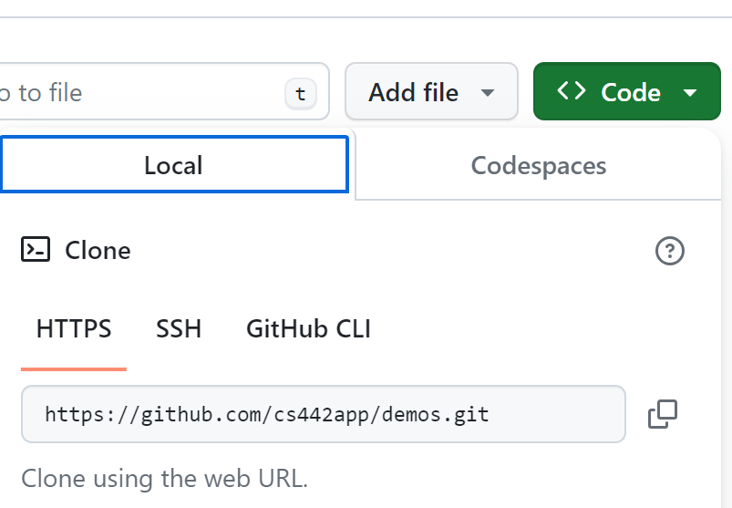

* Choose a location to copy the repository.
* Once copied, we can access that folder in VS code and now the local and web github are connected.
* To show up the changes we make locally to the website, there are some commands.
* Structure/concept behind :

When we clone the github repository to local, actually 2 copies get created (cloned copy and working folder). When we make changes to the file/folder, it gets updated in the working folder.

To bring the changes from working folder to cloned copy, we need an intermediate stage called staging.

* + Move the changes from working folder to staging 🡪 git add <file/foldername>

(git add .) 🡪used to move all changes made in the folder

* + Move the changes from staging to cloned copy 🡪 git commit -m “<commit comments>”
  + Move the changes from cloned copy to the orgin/github🡪 git push origin main
  + Move the changes from origin/github to working folder/vscode/local 🡪 git pull
* Create a folder locally and then make connection to github steps:
  + Create a local folder and add some files.
  + Make the folder a git repository by using 🡪 git init
  + To push it to github, we need this same named repository. So, create one in the github
  + Now back in vs code , as usual do, add/commit
  + Push can be done if there is connection and a main folder. So use this to make the connection 🡪git remote add origin <link of the new rep in github>
  + This would create a main branch named master (because of how git was designed oldtimes) – try “git branch” to see the branch name
  + To change the name from master to main, we can use 🡪git branch -m main

(we can also leave it be and use master instead of main in commands)

* New branch creation:Branches are created when many people work on the same project.Later, everyone’s work is collated into main branch
  + Create a branch in github. Click on main and start typing

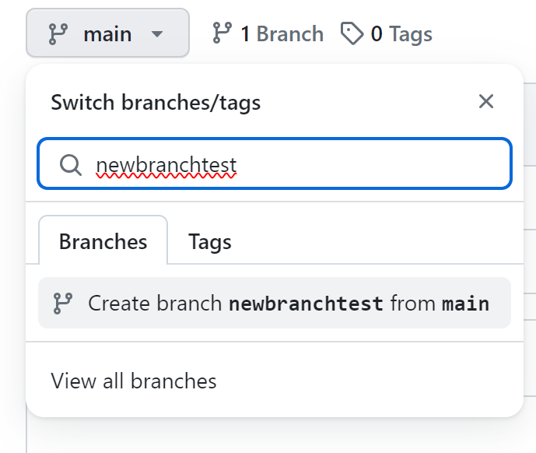

* + In vscode, use ”git branch -a” to see all branches and “git branch” to see current position
  + To move to diff branch use “git checkout <branchname>”
  + Updates are as usual – add/commit/push
  + To see the diff b/w current branch and another 🡪 git diff <branch2>
  + Merging branches – git merge <branch2> and then git push origin <branch>